http://ase1-env.us-west-2.elasticbeanstalk.com/conversion/pconvert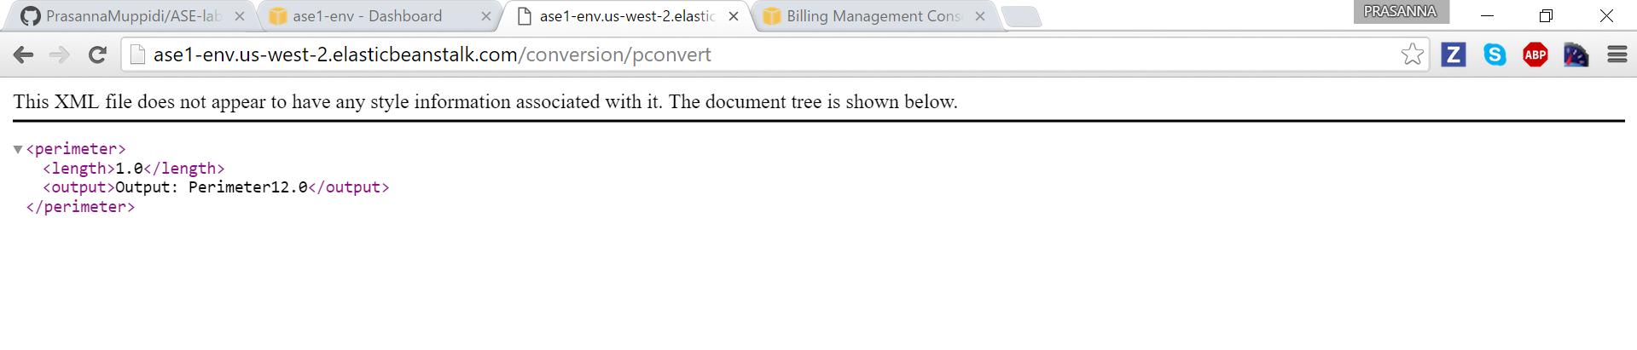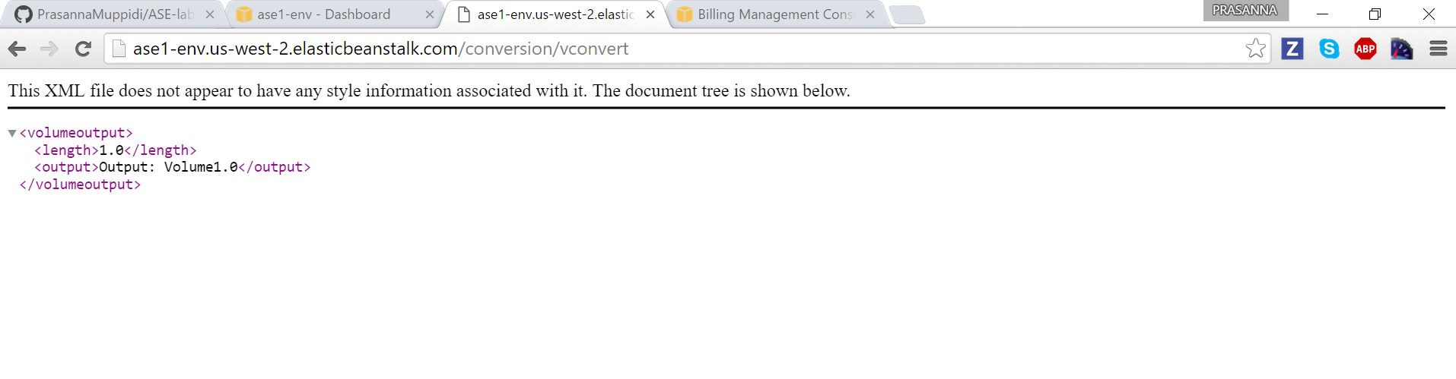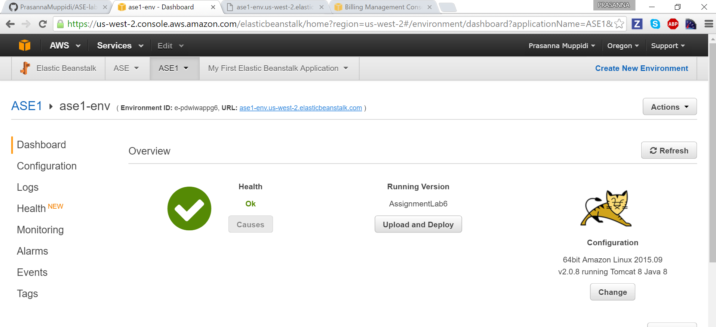

http://ase1-env.us-west-2.elasticbeanstalk.com/conversion/vconvert/4.5

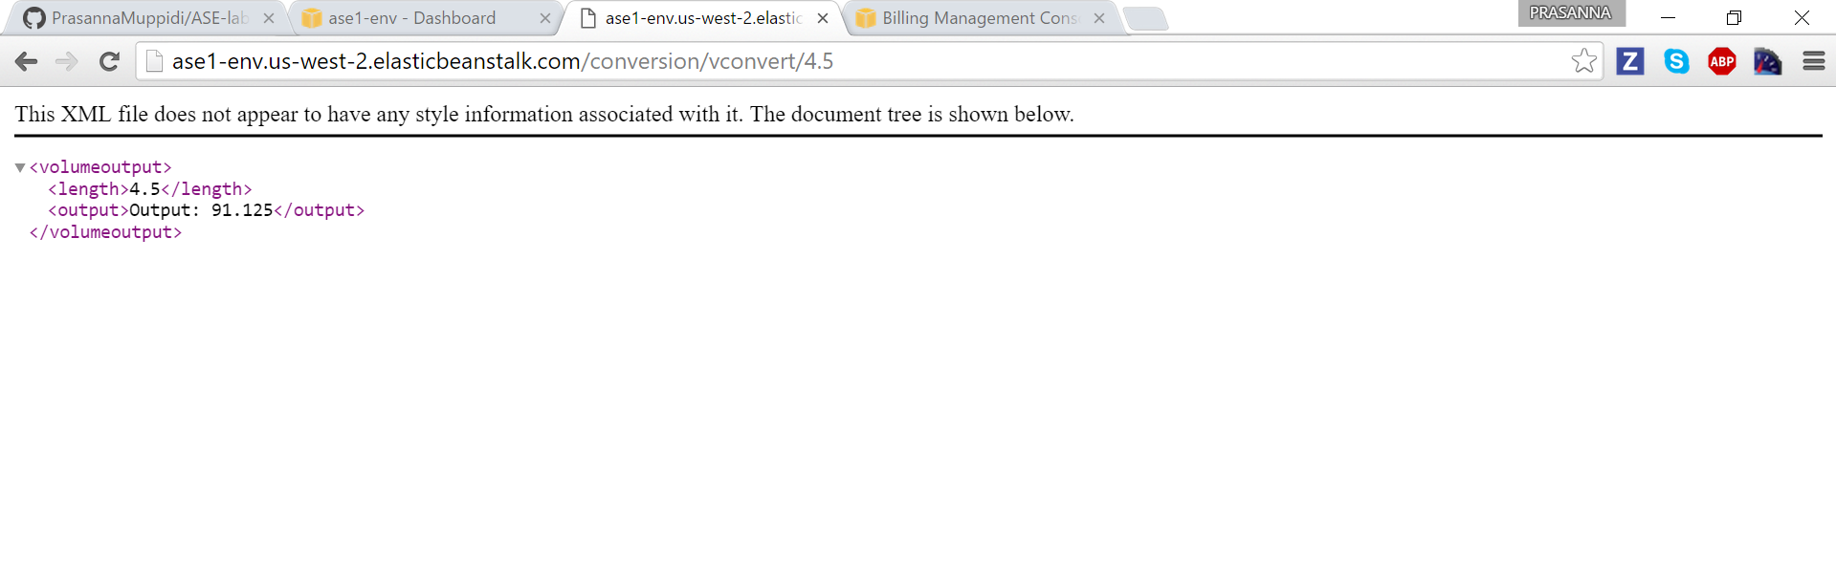

<http://ase1-env.us-west-2.elasticbeanstalk.com/conversion/pconvert/4.5>

